**LA GRANDEE INTERNATIONAL COLLEGE**

**Simalchaur – 8, Pokhara**

A Project Proposal

On

**Car Rental System**

**Submitted To**

LA GRANDEE INTERNATIONAL COLLEGE

Bachelor of Computer Application (BCA) Program

*In partial fulfillment of the requirements for the degree of Program Name under*

**Pokhara University**

**Submitted By**

|  |  |  |
| --- | --- | --- |
| **Name** | **Program, Semester** | **PU Registration No.** |
| Rikita Gharti | BCA IV | 2022-1-53-0138 |
| Subash Gurung | BCA IV | 2022-1-53-0147 |
| Namrata Bastola | BCA IV | 2022-1-53-0129 |
| R.A. MOHAN TIWARI | BCA IV | 2022-1-53-0136 |

May 2023

# Project Summary

The Car Rental System is a innovative desktop application developed using VB.NET to automate and enhance car rental operations. This digital solution aims to streamline the process of vehicle reservations, bookings, and cancellations within a car rental agency.

The primary focus of this program is to provide a user-friendly interface for staff to efficiently manage vehicle inventory, handle customer bookings, and process rental transactions. The system enables staff members, even those with basic computer skills, to access and utilize its features effortlessly.

Customers benefit from the simplicity of booking vehicles through multiple channels, including in-person visits to the rental agency or by contacting them via phone. This accessibility ensures that customers can quickly secure their desired vehicle without undue delay.

The Car Rental system is designed with scalability in mind, allowing it to adapt seamlessly to evolving business requirements. It follows an Agile methodology, allowing for continuous enhancement and adaptation to changing business needs. This iterative approach ensures that the system evolves incrementally, incorporating feedback and updates efficiently throughout the development lifecycle.

Built on the VB.NET platform, known for its reliability and ease of development, this system ensures optimal performance and robust functionality. The use of VB.NET also facilitates seamless integration with existing systems and databases commonly used in car rental businesses.

Overall, the Car Rental system developed with VB.NET is a valuable tool for car rental agencies, enabling them to efficiently manage bookings, attract new customers, and optimize revenue streams. By utilizing this system, rental businesses can streamline operations, minimize administrative overhead, and deliver exceptional customer service, enhancing overall business productivity and customer satisfaction.

# TABLE OF CONTENTS

Project Summary ii

1.Introduction 1

2. Problem Statement 2

3. Objectives 3

4. Methodology 4

4.1 Plan: 6

Define project goals and prioritize tasks in iterative sprints. 6

4.2 Design: 6

Create user stories, wireframes, and prototypes to guide development. 6

4.3 Develop: 6

Implement features incrementally, focusing on delivering value. 6

4.4 Test: 6

Conduct continuous testing to ensure quality and identify issues early. 6

4.5 Deploy: 6

Release working software at the end of each iteration. 6

4.6 Review: 6

Gather feedback, assess outcomes, and adapt plans for continuous improvement. 6

5. Deliverables 7

6.Data Flow Diagram: 9

7. Flowchart: 10

7.1. Start Menu: 10

7.2. Admin Menu: 11

7.3. User Menu: 11

8. Project Gantt Chart 12

# Introduction

In today's business landscape, technology is a driving force across various industries, including transportation services like car rentals. Computers and desktop applications have become indispensable tools for managing business activities efficiently, especially within the car rental sector. As the demand for convenient and flexible transportation solutions continues to grow, the car rental industry is poised for significant expansion this year.

The Fleet-Ease is a desktop-based application developed to streamline vehicle rental processes for both personal and business use. This system recognizes the increasing need for efficient digital solutions within the car rental market, offering customers a user-friendly platform to browse available vehicles, compare rental options, and make reservations effortlessly.

Similar to the demand for spa services, which cater to relaxation and wellness needs, car rental services cater to the mobility and transportation needs of individuals and businesses alike. The Fleet-Ease aims to meet these needs by providing a seamless booking experience through a desktop interface.

Users of the Car Rental System can explore various car rental agencies, review vehicle options, select rental durations, and complete bookings with ease. This system focuses on simplifying the reservation process, allowing customers to check vehicle availability, understand rental terms, and view associated costs upfront.

By leveraging desktop technology, the Car Rental System empowers users to access and book rental vehicles efficiently, supporting the growing demand for flexible transportation solutions. This innovative application is designed to optimize operations for car rental businesses and deliver exceptional customer service in today's dynamic and competitive market.

# 2. Problem Statement

The existing Car Rental booking systems often face challenges related to manual processes, inefficiency and customer dissatisfaction, leading to revenue loss and operational issues. These challenges highlight the need for modernized and streamlined approach to managing vehicle reservations

The problems before the proposal of this system were:

* **Time consuming and manual appointment scheduling:**

Our current booking process relies heavily on manual tasks, making it time-consuming for customers to reserve vehicles. This often leads to long waiting times and inconvenience.

* **Difficulty in managing appointments:**

With manual bookings systems, it’s challenging to effectively manage vehicle reservations, especially during peak periods. This can result in errors, missed bookings, and customer dissatisfaction.

* **Lack of customer convenience:**

Traditional booking methods limit customer convenience, as customers may need to allocate specific time slots to visit rental agencies. This inconvenience can lead to customer frustration and deter repeat business.

* **Tension due to manual recording:**

Manual record-keeping for vehicle reservations poses risks such as lost or damaged records, making it difficult for staff to manage bookings effectively. This can result in administrative burdens and operational inefficiencies.

To address these challenges and enhance the customer service of the Car Rental system, we are proposing the development of a digitalized car rental system. This system will utilize modern technology to automate and simplify our booking processes, providing customers with a seamless and convenient experience while improving our operational efficiency and overall business performance.

# 3. Objectives

The objective of this project is to develop a modernized Car Rental System using advanced technology to enhance the efficiency and effectiveness of our vehicle booking process.

The proposed objectives of our Car Rental System are:

* **Security and Data Privacy:**

To implement robust security protocols to ensure that only authorized personnel have access to customer information and booking details safeguarding data privacy and confidentiality.

* **User registration and Profile Management:**

To enable staff to register new customers seamlessly by capturing essential details such as name, contact number, email address and other relevant information required for vehicle bookings.

* **Vehicle Booking Management:**

To provide staff with tools to efficiently manage vehicle reservations, including adding new bookings, cancelling existing reservations and accommodating rescheduling requests based on customer preference and availability.

* **Intuitive and User-Friendly interface:**

To develop a user-friendly interface that simplifies navigation and reduces the risk of errors, empowering staff to manage bookings efficiently and effectively.

* **Dynamic Price Management and Policy Implementation:**

To equip authorized personnel with the ability to adjust rental prices in alignment with business policies and market trends, ensuring competitiveness and profitability within the Car rental industry.

By achieving these objectives, our Car Rental System will optimize operational workflows, elevate customer service standards, and position Fleet-Ease as a leader in providing convenient and reliable vehicle rental service applications. This digital solution will enhance overall business performance and customer satisfaction, driving success and growth in the competitive car rental market.

# 4. Methodology

For the development of the Car Rental System, we will adopt the Agile methodology. Agile is a flexible and iterative approach to software development that emphasizes collaboration, adaptability, and continuous improvement throughout the project lifecycle.

Using the Agile methodology, our development process will involve:

* + Iterative Development:

We will break down the project into manageable iterations or sprints, with each iteration delivering working software that adds value to the system.

* + Continuous Feedback and Adaptation:

We will engage stakeholders, including internal teams and customers, to gather feedback regularly. This feedback will drive ongoing improvements and refinements to the system.

* + Cross-Functional Teams:

Our development teams will be cross-functional, comprising members with diverse skills (e.g., developers, testers, designers). This setup fosters collaboration and collective ownership of project goals.

* + Emphasis on Customer Collaboration:

We will prioritize customer collaboration throughout the development process to ensure that the Car Rental System meets their evolving needs and expectations.

* + Responding to Change:

Agile allows us to respond quickly to changing requirements and market dynamics by embracing flexibility and adaptability in our development approach.

By leveraging Agile principles and practices, we aim to deliver a high-quality Car Rental System that aligns closely with customer requirements, enhances user experience, and accelerates the delivery of value to our business and customers. This iterative and customer-centric approach will enable us to optimize project outcomes and drive success in the competitive car rental industry.

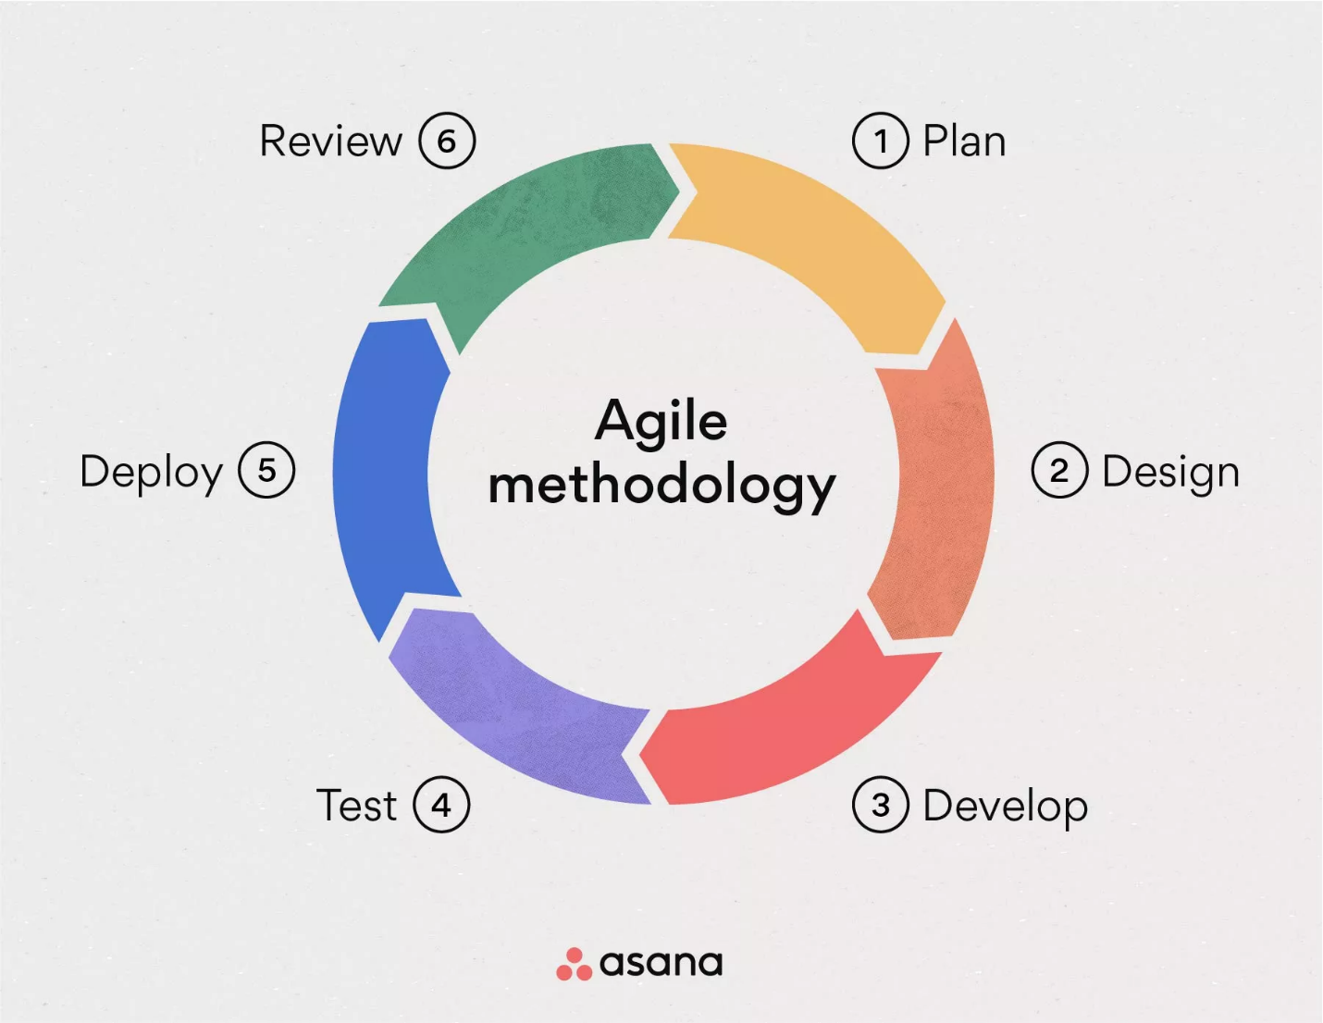Fig 4.1: Agile Methodology

## 4.1 Plan:

## Define project goals and prioritize tasks in iterative sprints.

## 4.2 Design:

## Create user stories, wireframes, and prototypes to guide development.

## 4.3 Develop:

## Implement features incrementally, focusing on delivering value.

## 4.4 Test:

## Conduct continuous testing to ensure quality and identify issues early.

## 4.5 Deploy:

## Release working software at the end of each iteration.

## 4.6 Review:

## Gather feedback, assess outcomes, and adapt plans for continuous improvement.

# 

# 5. Deliverables

The Fleet-Ease is designed to streamline vehicle reservation processes and enhance customer service within our car rental business.

The deliverables of the proposed Car Rental System are as follows:

* Source Code and Application Development:

Develop the system using VB.NET, leveraging its functionalities and libraries to create a robust and efficient desktop application.

* Database Implementation:

Design and implement a database to store vehicle information, customer details, booking records, and other relevant data necessary for managing car rentals.

* Authentication and Access Control:

Implement an authentication system to ensure secure access, allowing only authorized users to perform booking operations and manage rental information.

* Vehicle Reservation Management System:

Develop a comprehensive system to facilitate vehicle reservations, modifications, cancellations, and viewing of rental bookings with intuitive user interfaces.

* Testing and Quality Assurance:

Conduct thorough testing and debugging of the system to identify and resolve any issues, ensuring the functionality and reliability of the Car Rental System.

* Comprehensive Documentation:

Prepare detailed documentation that outlines the usage and functionality of the Car Rental System, including installation instructions and configuration guidelines.

* Deployment and User Accessibility:

Deploy the finalized application for seamless access by end-users, ensuring it is ready for operational use within our car rental business.

By achieving these deliverables through the development of the Car Rental System using VB.NET, we aim to modernize our vehicle booking processes, improve operational efficiency, and deliver an exceptional experience for our customers and staff alike. This comprehensive solution will contribute to the growth and success of our car rental services in today's competitive market.

# 6. Data Flow Diagram:

# 7. Flowchart:

## 7.1. Start Menu:

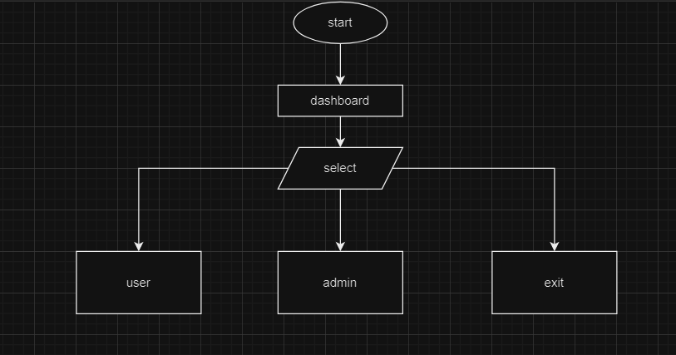

## 7.2. Admin Menu:

## 7.3. User Menu:

# 8. Project Gantt Chart

